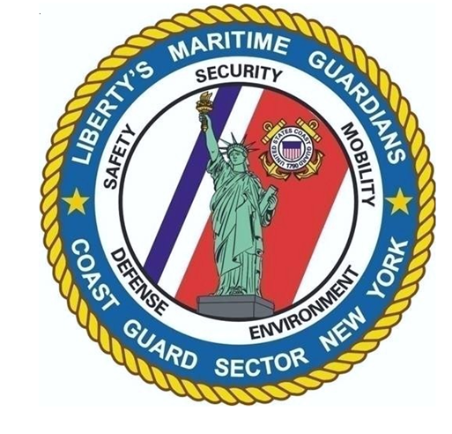
SECTOR NEW YORK ENGINEERING


SCOPE OF WORK

FOR

REPAIR LEAKING WATERLINE
PROJECT #: SECNYHABSAUG01

AT

U.S. COAST GUARD
AIDS TO NAVIGATION TEAM SAUGERTIES
154 LIGHTHOUSE DR.
SAUGERTIES, NY 12477
TABLE OF CONTENTS

DIVISION 1 – GENERAL REQUIREMENTS

01 10 00 SUMMARY OF WORK

DIVISION 33 – SITE UTILITIES

33 11 00 WATER UTILITIES

ENCLOSURES

Enclosure (1) – Drawing #: P01P4419 – Civil Site Plan

SECTION 01 11 00

SUMMARY OF WORK

PART 1 GENERAL

1.1 WORK COVERED BY CONTRACT DOCUMENTS

1.1.1 Project Description & Identification

The work for this project is defined by the contract documents and consists of the following:

- In general, this project consists of all work, including labor, equipment and materials necessary to repair a known main waterline leak on the piping coming directly off the city water main.

This project shall be referred to as Project #: SECNYHABSAUG03 – ANT Saugerties – Repair Leaking Waterline.

1.1.2 Location

The work is located at:
Coast Guard Aids to Navigation Team (ANT) Saugerties
154 Lighthouse Drive
Saugerties, NY 12477.

1.3 requests for information

Prior to submission of bid, project questions shall be submitted in writing as a Request for Information (RFI) to the Contracting Officer (KO). After contract award and during construction, if site conditions differ significantly from these plans and specs, contractor shall submit an RFI to the KO in writing detailing the issue and recommend a solution for government review/approval.

1.4 Site visit

Although not required contractors are welcome and encouraged to make a site visit to determine existing conditions and verify project elements during bidding. A site visit will be held on November 17th, 2026 at 11:00 am. Interested contractors must RSVP to the COR if they wish to attend.

1.5 POINTS OF CONTACT

Contracting Officer’s Representative
Sector New York Engineering
311 Battery Rd.
Staten Island, NY 10305
LT Claire Sullivan
Email: Claire.V.Sullivan@uscg.mil

PART 2 PRODUCTS

Not used.

PART 3 EXECUTION

Not used.

-- End of Section --
SECTION 33 11 00

WATER UTILITIES

PART 1 GENERAL

1.1 summary

- Scope: Work in this section includes the repair of a leaking utility water line located in a valve box connected to a 6-inch city water main. The valve box is located just inside the property line of Coast Guard ANT New York.

- Scope includes:
  - Isolation, depressurization, and coordination of temporary shutdown with the Saugerties New York Water Department.
  - Removal and replacement of defective valve, fittings, and/or short sections of pipe to restore watertight integrity.
  - Replacement or adjustment of valve box and cover as needed.
  - The contractor shall provide a minimum one-year warranty on all parts and labor.

1.2 REFERENCES

- New York State Building Code (NYSBC), Plumbing and Utility Provisions.
- New York State Department of Health (NYSDOH) – Part 5, Subpart 5-1, Drinking Water Supply Regulations.
- Village of Saugerties Water Department – Standard Specifications for Water System Construction.

1.3 project conditions

- Contractor shall coordinate with Saugerties Water Department for line shutdown, inspection, and approval of repairs.
- Maintain safe pedestrian and vehicular access during repairs.
- Provide temporary potable water supply if shutdown exceeds 8 hours.

1.4 SUBMITTALS

- Product Data: Valves, fittings, repair clamps, gaskets, pipe material.

PART 2 PRODUCTS

2.1 pipe and fittings

- Ductile Iron Pipe (DIP), Class 52, cement-mortar lined, conforming to AWWA C151 or piping conforming to Village of Saugerties standards.
- Fittings: Ductile iron, mechanical joint, conforming to AWWA C110/C153.

2.2 valves

- Resilient-seated gate valve, AWWA C509 or C515, mechanical joint ends, 200 psi minimum pressure rating.

PART 3 EXECUTION

3.1 EXAMINATION & PREPARATION

Do not begin the project until site conditions have been thoroughly examined. Coordinate with the Saugerties Water Department of Water for shutdown if required. Pump water from the valve box and determine leaking components. Restore water until materials arrive for repairs.
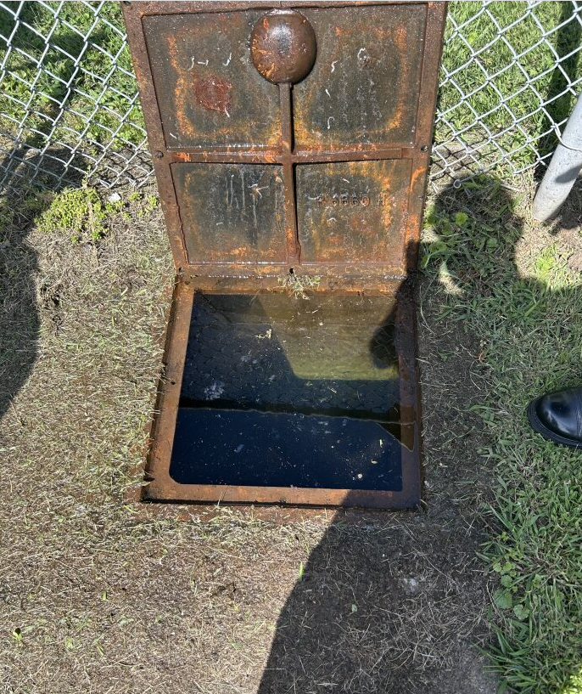
Figure 1 - Flooded Valve Box

3.2 pipe and valve repair

Coordinate shutdown with Saugerties Water Department if necessary. Freeze plumbing, use insertion valve, or another industry standard for securing water if the city is unable to shutdown water. Remove defective components including valve, fittings, or section of pipe that are damaged. Install new valve, fittings, or section of pipe per AWWA and Saugerties standards. Verify watertight seal under normal operating pressure.

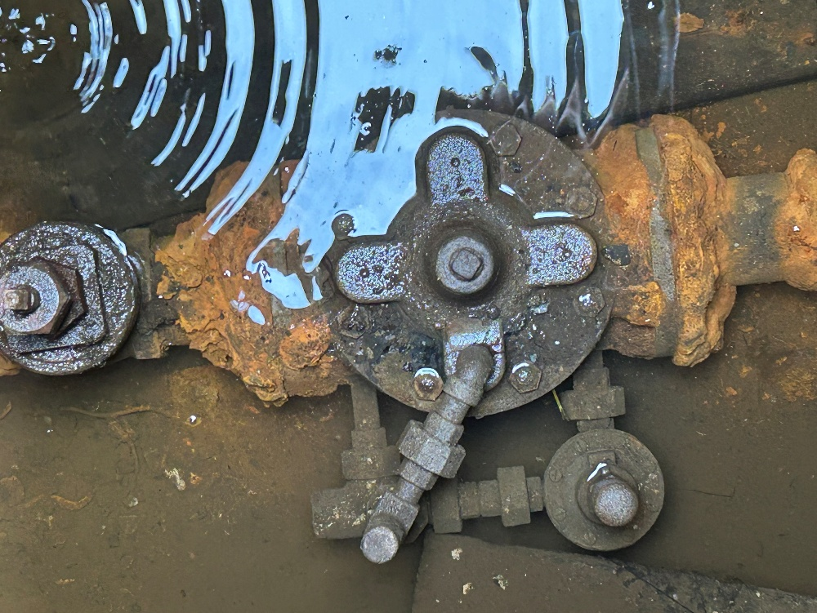
Figure 2 - Photo of Valve in Box (Presumed Cause of Leak)

3.3 disinfection & testing

A. Disinfect repaired section per AWWA C651 and NYSDOH Part 5 regulations.
B. Perform hydrostatic pressure test at 150 psi for 2 hours with zero leakage permitted.

-- End of Section --

